**7. Introduction to Kubernetes Ingress Class Resource**

--- **note** – lets understand the problem here and where the ingress class comes into the picture.

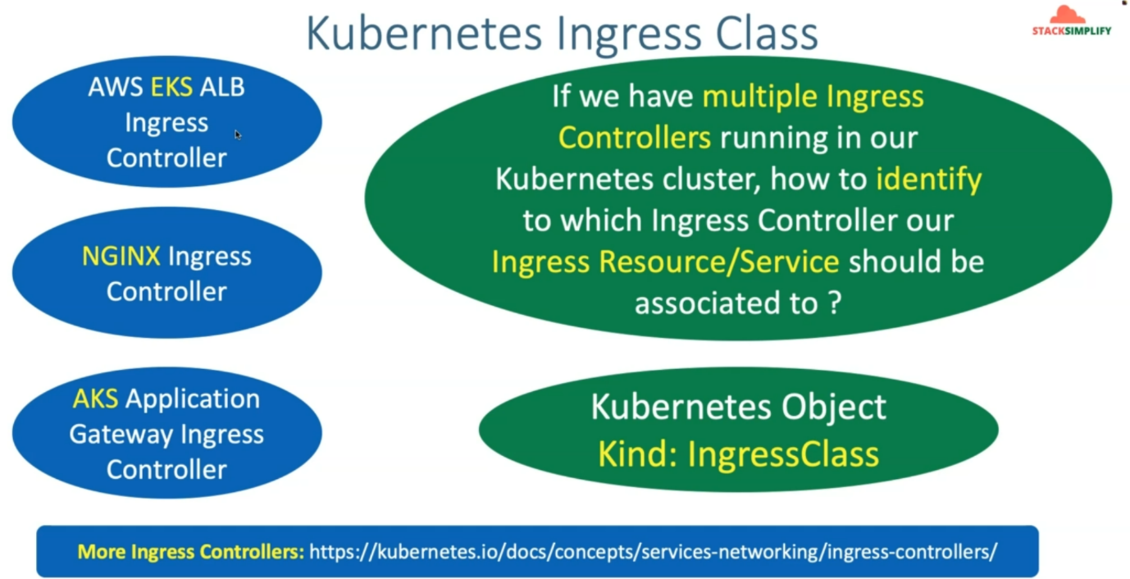

--- if you take your Kubernetes cluster, you have EKS related AWS load balancer installed on your Kubernetes cluster and also you are running the nginx ingress controller and you are also running **AKS** application gateway ingress controller.

--- **NOTE** - multiple ingress controllers are running in our Kubernetes cluster and you have deployed you are ingress resource using kubectl or ingress service, and that ingress service is associated to which Ingress Controller so there comes the concept called. Kubernetes object kind.

--- **note** – only these 3 ingress controllers, there are many ingress controllers are available in the marker.

**Difference between ingress class and ingress resources**

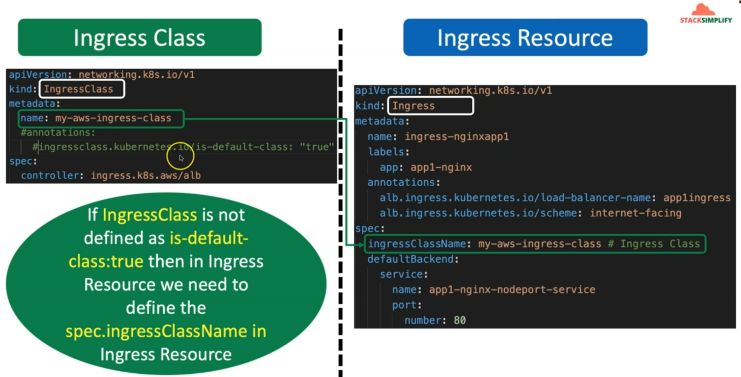

--- **ingress resources** – the ingress resource is nothing but it like you are going to create an application load balancer using kubernetes manifests.

--- **annotations: load balancer name is app1ingress**, here we mentioned the load balancer name.

--- **scheme: internet-facing** - It creates the application load balancer in aws as an internet facing load balancer.

--- **spec:ingressClassName** – **my-aws-ingress-class** – this name should match with name, we created before in the ingressclass.

--- **note** - if ingressclass is not defined as **is-default-class:true** then in ingress resource we need to define the spec.ingress Resource, if you do this then this ingress resource is directly associated with aws application load balancer.

**Eg spec**:

**Controller: ingress.k8s.aws/alb**.

--- note – in the ingressclass there is 2 lines commented out, if you enable those line then you don’t need to right **spec: ingressclassname:my-aws-ingress-class** in ingress resources because

**Ingress Class Concept**

--- Understand what is Ingress Class

--- Understand how it overrides the default deprecated annotation #kubernetes.io/ingress.class: "alb"

--- Ingress Class Documentation Reference - <https://kubernetes-sigs.github.io/aws-load-balancer-controller/v2.4/guide/ingress/ingress_class/>

--- Different Ingress Controllers available today - <https://kubernetes.io/docs/concepts/services-networking/ingress-controllers/>

**Review IngressClass Kubernetes Manifest**

--- File Location: 08-01-Load-Balancer-Controller-Install/kube-manifests/01-ingressclass-resource.yaml

--- Understand in detail about annotation ingressclass.kubernetes.io/is-default-class: "true"

apiVersion: networking.k8s.io/v1

kind: IngressClass

metadata:

  name: my-aws-ingress-class

  annotations:

    ingressclass.kubernetes.io/is-default-class: "true"

spec:

  controller: ingress.k8s.aws/alb

## Additional Note

# 1. You can mark a particular IngressClass as the default for your cluster.

# 2. Setting the ingressclass.kubernetes.io/is-default-class annotation to true on an IngressClass resource will ensure that new Ingresses without an ingressClassName field specified will be assigned this default IngressClass.

# 3. Reference: https://kubernetes-sigs.github.io/aws-load-balancer-controller/v2.3/guide/ingress/ingress_class/

--- **note** - **annotations:kubernetes.io/is-default-class: “true”** - it is set to true, because of this any ingress resources created inside of this kubernetes cluster will be associated with application load balancer controller.

**Create IngressClass Resource**

**# Navigate to Directory**

--- **cd 08-01-Load-Balancer-Controller-Install**

**# Create IngressClass Resource**

--- **kubectl apply -f kube-manifests**

**# Verify IngressClass Resource**

--- **kubectl get ingressclass**



**# Describe IngressClass Resource**

--- **kubectl describe ingressclass my-aws-ingress-class**

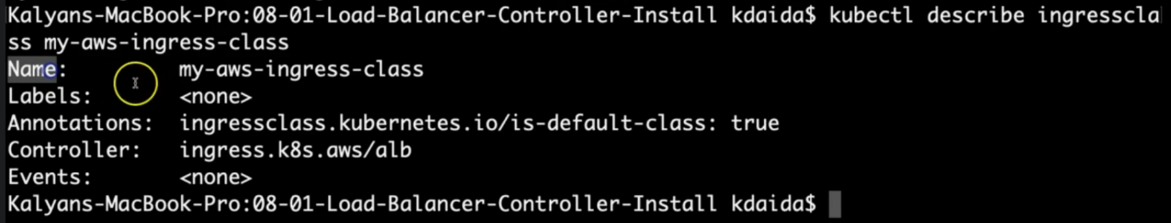

--- References

--- AWS Load Balancer Controller Install - <https://docs.aws.amazon.com/eks/latest/userguide/aws-load-balancer-controller.html>

--- ECR Repository per region - <https://docs.aws.amazon.com/eks/latest/userguide/add-ons-images.html>